What “Climate Science” is Not About
By Howard “Cork” Hayden, The Energy Advocate, January 2025

Al Gore’s movie An Inconvenient Truth left some lasting—and very incorrect—impressions. One of them is shown near the tip of his finger in the figure to the right, as he correctly points out that “some of this infrared radiation is trapped by the earth’s atmosphere and warms it.”

There is no doubt that only about 60% of the amount of radiant emission from the surface goes into space, and there is no doubt that the difference is mostly caused by atmospheric gases (some is due to clouds). But the misleading implication is that “climate scientists”—the ones who assert that “greenhouse gas pollution has caused most of the warming of the last 50 years” quoted in the same movie—are experts in the science of the greenhouse effect.

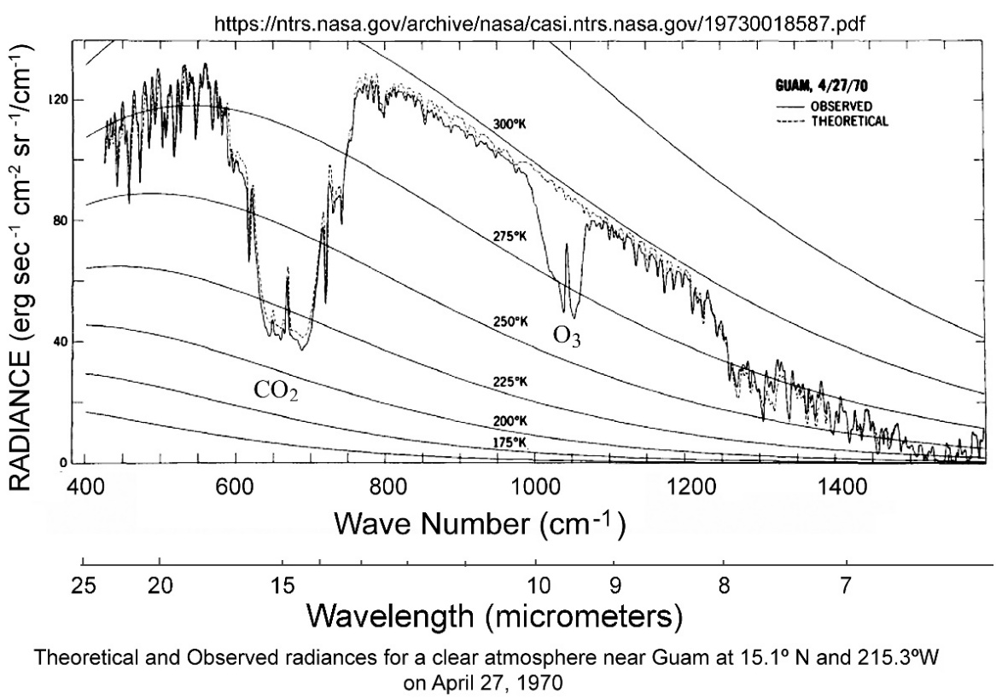
Figure 1: IR spectrum for a clear atmosphere observed over Guam, April 27, 1970
In 1970, the Nimbus satellite flew over Guam and measured the spectrum of infrared (IR) going to space. The graph shown in Figure 1, has numerous features of interest. The smooth curves show blackbody spectra at various temperatures. For example, the 300 K (Kelvin; absolute) line is a bit higher than that of the surface of the earth at about 288 K. The jagged line shows the measured IR spectrum, which might be regarded as a blackbody spectrum with big bites removed by CO₂, ozone (O₃), and H₂O (primarily left and right ends of the spectrum).

The theoretical curve, calculated from molecular spectra, is a very good fit, save for the O3 region that was ignored.

The surface of the earth emits a smooth blackbody spectrum, and the interactions between IR and various atmospheric gases (lovingly called greenhouse gases) are what causes the jagged spectrum emitted to space. Less IR goes to space than is emitted by the surface.

As you can imagine, calculation of the spectrum of IR emitted to space is quite involved; how could it be otherwise, with such a jagged line? To make a long story short, it involves quantum mechanics (the quantitative nature of vibrational and rotational states of molecules), molecular spectroscopy (how various wavelengths of IR interact with molecules at what temperatures and atmospheric pressures), and statistical mechanics (the temperature-dependent populations of excited states).

The term greenhouse effect is used as a shorthand descriptive of all those processes that change the nature of the spectrum and the reduction of IR intensity caused by greenhouse gases (GHGs).

For all the talk about how CO2 is killing the planet, how we have to limit “carbon emissions,” and how we must use “carbon-capture technologies,” you would think that “climate science” is a scientific field about the greenhouse effect.

You would be wrong.

Choose any college or university offering a degree in Climate Science. Look up the course offerings and the degree requirements. Read every word. Look for any reference to quantum mechanics, molecular spectroscopy, or statistical mechanics. You will find none.

Now, pore over IPCC’s six Assessment Reports. Look for any mention of the spectra of any greenhouse gases. Look for any discussion of how IR interacts with greenhouse gases, even the dreaded CO2. Look for any discussion of how the atmosphere converts the smooth blackbody spectrum emitted by the surface into the jagged spectrum of IR going to space. Look for any graph of any spectrum whatsoever. You will find only one, and it is laughably incorrect. We’ll discuss that problem later.

To put it fairly, but bluntly, “climate science”—whatever its merits—is not the science of the greenhouse effect.

