Capacity Factor
By Howard “Cork” Hayden
The Energy Advocate, February 2025

The capacity factor is defined as the long-term (usually annual) average amount of power produced compared to the nameplate power. Nuclear power stations operate at about 92% capacity factor; their job is to provide baseload power, and stability is best achieved with steady power output.

By contrast, hydro power stations are overbuilt. They can provide massive amounts of power for periods of high demand. As they do so, the water level behind the dam runs down, but will return to the high level during the hours after the turbines are shut off. For example, the capacity factor of Hoover Dam is only 23%, while that of Grand Coulee Dam is 36%. Natural gas plants can cycle power up and down fairly rapidly—many go from zero to full power in 15 minutes—so they are used for base power (combined-cycle units with 60% efficiency) as well as for load-chasing—keeping line voltage steady while demand fluctuates.

The capacity factor for solar is determined by location and weather. Set up some solar panels facing the noonday sun, and you get a few hours of almost full power and the rest of the time low power or none at all. That the capacity factor for US solar photovoltaics is 24.6% (Figure 1) tells us that solar panels have been placed in very favorable locations (see nearby solar map).

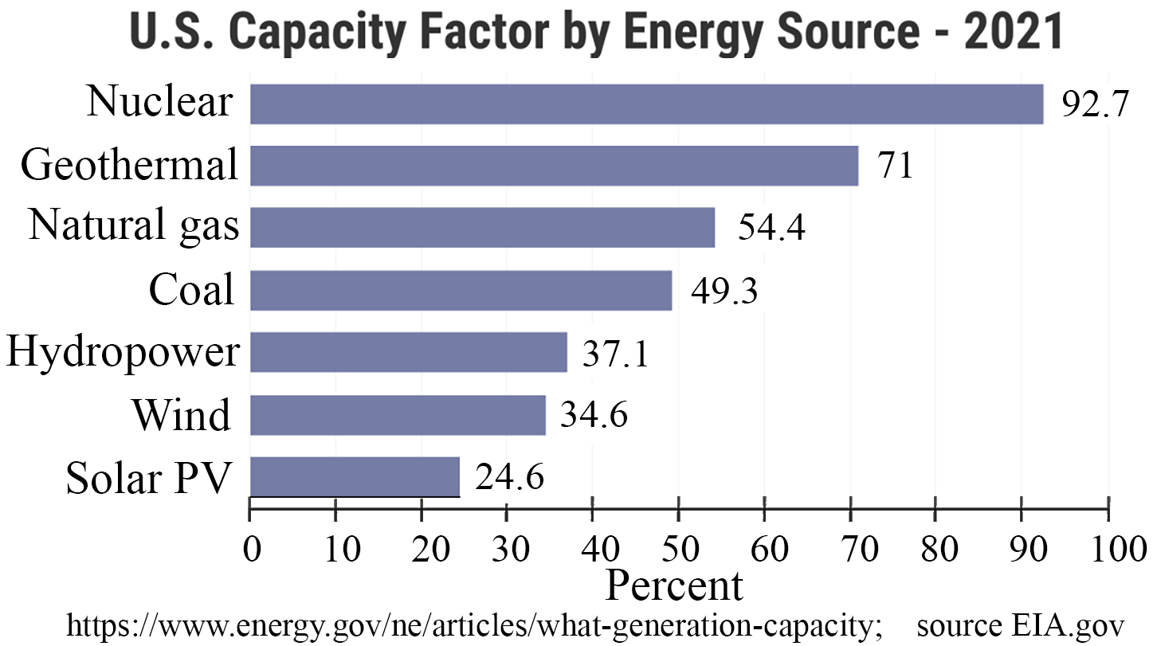

Figure 1: Capacity factors for our energy sources.
That the capacity factor for US solar photovoltaics is 24.6% (Figure 1) tells us that solar panels have been placed in very favorable locations (see nearby solar map).
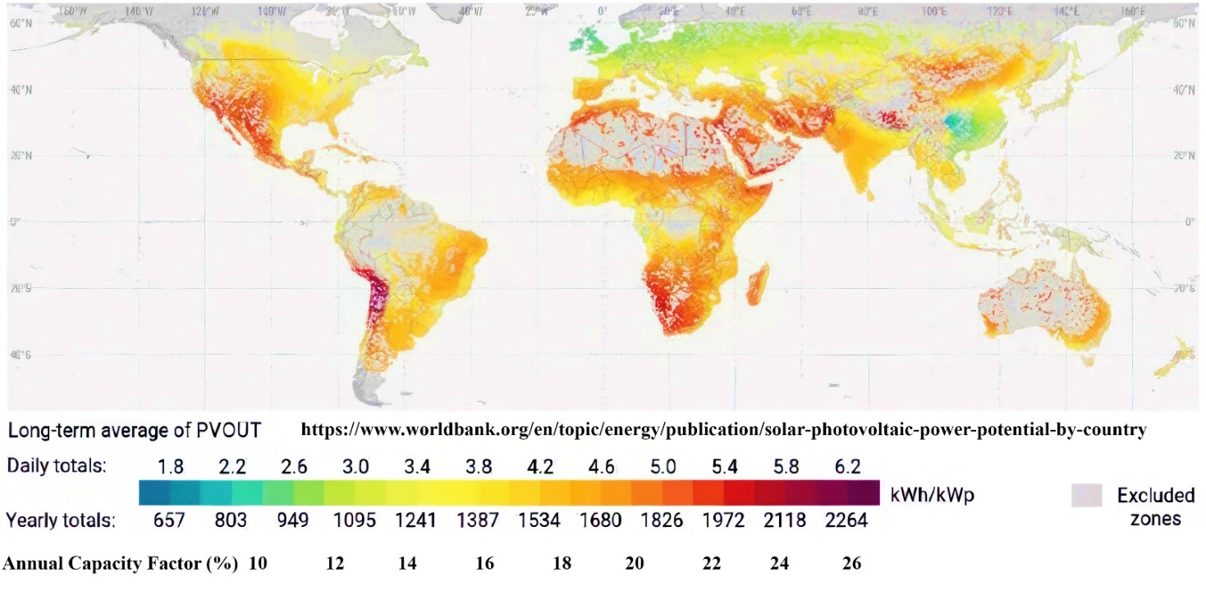
The capacity factor of wind turbines is a matter of engineering. You can get any value you want from 0% (huge generator driven by tiny wind turbine) to 100% (tiny generator turned by giant wind turbine). In the 1970s, the decision was to settle on a capacity factor of 20%, largely because they could advertise that their devices produced a lot of power (typically 100 kW or 200 kW at the time). Later, the engineering compromise was to design systems around a capacity factor of 35% was based on more sensible economics.

Efforts to Make Unreliable Energy Reliable
It all sounds so simple. Store energy when the sun shines and/or the wind blows, and use it when you need it.

There are four generic ways to store energy: mechanical, thermal, chemical, and electrical.

Pumped-hydro is the classic energy-storage routine. When there is excess electricity available, pumps move water from a lower reservoir to an upper one where it is stored behind a dam. When more electricity is needed, the water is released through turbines. This system has been used for many years—where the system is feasible—to supplement conventional power for a few hours per day when demand is high.

I have seen proposals to use excess electricity from wind turbines to lift weights up the towers to accomplish the same task. A 10,000 kg (ca. 11 tons) block elevated 100 meters (330 feet) has a potential energy of 107 joules, equivalent to 2.8 kWh. That’s enough to replace one megawatt of the turbine for a whopping 10 seconds.

The Ivanpah project in the Mojave Desert consisted of a huge array of 350,000 computer-controlled mirrors that reflect sunlight onto absorbers on towers to produce electricity with steam generators. They store excess energy as heat in molten salt. Financially, Ivanpah can’t compete with solar-PV installations, so its contracts are being cancelled [4]:
Pacific Gas & Electric said in a statement it had agreed with owners — including NRG Energy Inc. — to terminate its contracts with the Ivanpah plant. If approved by regulators, the deal would lead to closing two of the plant's three units starting in 2026. The contracts were expected to run through 2039.

A chemical scheme that has some people excited is to store energy by separating hydrogen (H2) from water (H2O). The advantage is that hydrogen can be used in fuel cells to produce electricity directly at about 50% efficiency. Hydrogen can be stored in high-pressure tanks, but there must be a shield (such as Al2O3) between the hydrogen and the steel tank, because the hydrogen can permeate through steel and make it brittle. (This was the cause of the sinking of many early Liberty Ships that encountered rough seas on the way to Europe in WW-II.)

Finally, we come to batteries. There is a big demand for lithium these days because lithium is the lightest metal in the Periodic Table, and it is highest in the electromotive series table. Those traits make it desirable for transportation purposes.

For stationary purposes, there is no need for the material to be light in weight. We all have experience with at least some of these batteries: carbon-zinc, alkaline, silver-oxide, zinc-air, lithium ion, nickelmetal hydride, leadacid, and nickelcadmium. All the batteries in the list are rechargeable except for the first three. What matters is that batteries can be made from many materials. For purposes of backing up solar and wind, the requirements of a battery are low material cost, the ability to be charged and discharged at high rates, at least ten years of service life, guaranteed safety, and massive storage capability.

Let us suppose that we have a renewable energy system that can produce a year-round average power of 1,000 MW with nameplate power (achieved at times) of 4,000 MW. Let us further suppose that at some stage, the back-up batteries are fully charged and for some reason the renewable energy system can produce no power for 24 hours. The battery array must have 24,000 MWh of energy storage. That’s the amount of energy stored in 320,000 automotive Tesla battery packs.

Batteries produce electricity by reacting dissimilar.
chemical elements, both of which are in the battery, separated
by an electrolyte. In case of an accident—usually with damage
to the electrolyte—the two chemicals in some batteries can
interact directly, producing heat (hence a fire if enough heat is
released).

The largest battery array in the world is a bit shy of 1,000 MW, but has about 50% more storage capacity [5]:

The Moss Landing Power Plant is a natural gas powered electricity generation plant as well as a battery energy storage facility, located in Moss Landing, California, United States, at the midpoint of Monterey Bay. As of 2024, the site's battery storage facility is the largest in the world, at 930 MW (power) and 3,700 MWh (energy).

There was a recent fire at the Moss Landing battery installation [7] which used nickel-manganese-cobalt (NMC) lithium-ion cells. The cause of the fire has yet to be determined [7,8] Following protocol, the fire department let the fire burn itself out. There have been no published data on the extent of the damage. That is, nobody has said how much of the battery assembly or of anything else was damaged.

What do crystal balls tells of the future market for batteries? We read [6]:

The global cumulative energy storage capacity is forecasted to reach 650 gigawatts (or 1,877 gigawatt-hours) by the end of this decade, according to a new analysis by BNEF [Bloomberg New Energy Finance].

[4] Michael R. Blood, “11 years after a celebrated opening, massive solar plant faces a bleak future in the Mojave Desert,” January 30, 2025, https://www.yahoo.com/news/11-years-celebratedopening-massive-000749414.html Thanks to Willie Soon

[5] https://en.wikipedia.org/wiki/Moss_Landing_Power_Plant

[6] https://www.kallanish.com/en/news/power-materials/marketreports/article-details/global-energy-storage-capacity-to-reach650gw-by-2030-bnef-1023/?gad_source=5&gclid=EAIaIQobCh
MI4fWm192oiwMV_ihECB0X8DXqEAAYBSAAEgJgI_D_BwE

[7] Olga R. Rodriguez and Isabella O’Malley, “Smoke from fire at California lithium battery plant raises concerns about air quality,” January 17, 2025, https://apnews.com/article/batterystorage-plant-fire-california-moss-landing7c561fed096f410ddecfb04722a8b1f8

[8] Ric O’Connell, “Building a Safer Storage Industry After the Moss Landing Fire,” https://www.powermag.com/building-a-saferstorage-industry-after-the-moss-landing-fire/

